Intermediate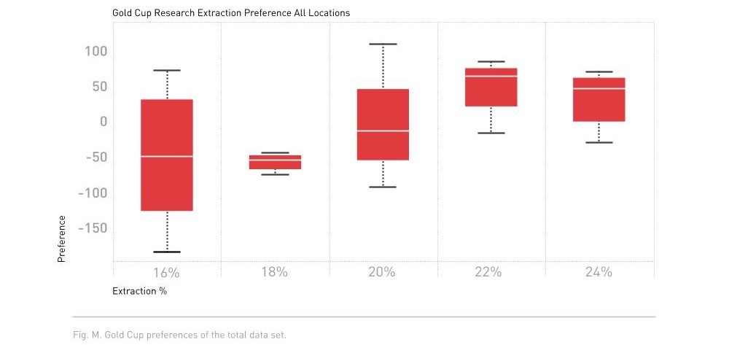

#### SCAE 2013 Extraction Preference Study

Found that current preferences in included nations was in line with findings from the Coffee Brewing Centre published in the ________.

**Supports the current SCA Gold Cup Range of** ________ **extraction yield.**

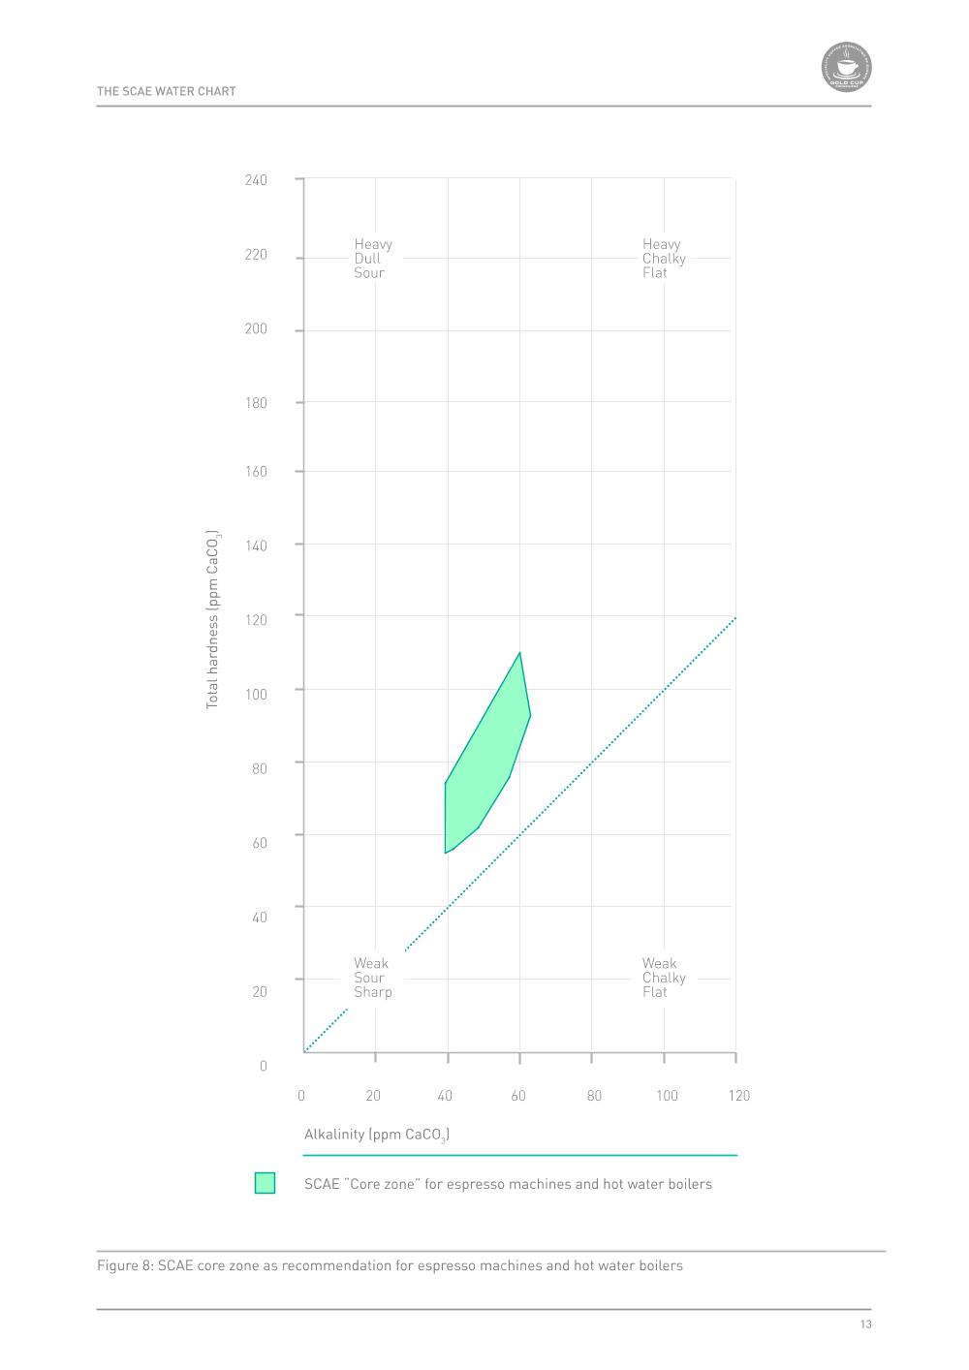

#### SCAE Water Quality Report

Covers chemical composition of water as it relates to brewing coffee. Outlines recommended criteria for mineral concentration and sets standards for water quality.

Establishes a “________________” process for treating water that is outside of the core zone for mineral concentration.

**Alkalinity** is defined by a solution’s ability to neutralize acids and measured by CaCO₃ concentration.

Desired alkalinity range is __________ ppm CaCO₃.

**Total Hardness** is defined by the sum of Calcium and Magnesium in equivalent concentrations and is measured by CaCO₃ concentration.

Desired total hardness range is ___________ ppm CaCO₃.

**Carbonate Hardness** is essentially what determines the total amount of scale (as CaCO₃) that can form. It is equal to either the Total Hardness or Alkalinity, whichever is lower.

Add pH range

#### “Brewing”

The brewing process is the release of CO₂ and the dissolution of organic compounds inside coffee. There are many types and groups of soluble compounds in coffee and they will extract at _________ rates.

There are certain elements needed for brewing high quality coffee.

* High Quality Water
* Choose a Brewing Method
* Grinding Fresh with a Quality Grinder
* Appropriate Filtering Method
* Correct Coffee:Water Ratio
* Proper Technique

**Extraction Yield** is what percentage of the coffee bean, including non-soluble solids, was dissolved out of the ground coffee and in to water. The total possible amount of coffee that can be dissolved out is determined by the coffee plant variety, environmental factors, and roast development/profile, but ranges between _____________ or most usually ~ ______.

#### Stages of Extraction

1st Group:

Smaller, faster moving, more easily soluble, will be the first solids to extract.

Contribute acidity, complexity, high concentration of solubles contributes heavy texture (i.e. brew strength/concentration)

2nd Group:

Larger molecules, less soluble, slower moving compounds, will begin to extract later than acids. Contributes sweetness, umami, affects overall balance.

3rd Group:

Largest molecules, least soluble, slowest moving compounds, will begin extracting much later. Contributes bitterness, texture, affects overall balance.

**Tasting Activity #1 Stages of Extraction**

*Write notes describing flavors, texture, and aroma for each part of the brew.*

*1st Stage:*

*2nd Stage:*

*3rd Stage:*

#### Ideal Extraction

**SCA Gold Cup Extraction Range** is:

Adjustments and changes to overall extraction yield will affect flavor qualities.

**Tasting Activity #2 Tasting changes in extraction yield**

*Write notes describing flavors, texture, and aroma for each brew*

*Brew #1*

*Calculated extraction:*

*Notes:*

*Brew #2*

*Calculated extraction:*

*Notes:*

*Brew #3*

*Calculated extraction:*

*Notes:*

#### Strength Concentration

**SCA Minimum Recommended TDS is:**

Adjustments and changes to strength will affect flavor intensity and mouthfeel.

**Measuring TDS %(Strength)**

TDS is **T**otal **D**issolved **S**olids, meaning the concentration of coffee solids vs water molecules in the brewed coffee. Refractometers measure the difference between refraction from a known, and the unknown sample to determine the refraction index of the sample. Coffee refractometers convert the information in to TDS for coffee.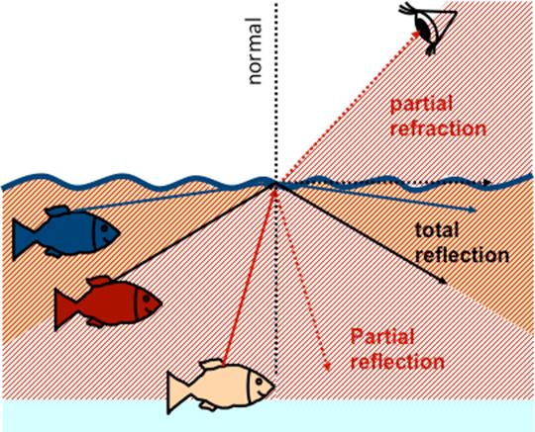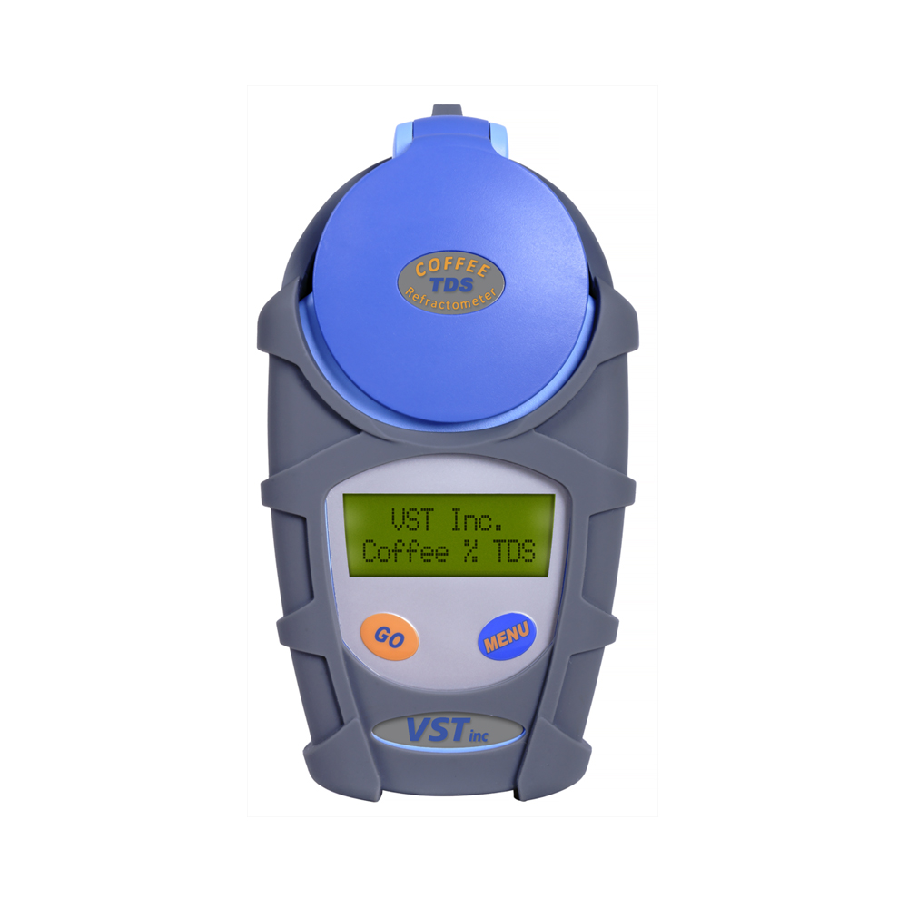

*https://wiki.anton-paar.com/en/basics-of-refractometry/*

**Tasting Activity #3 Tasting differences in concentration**

*Write notes describing flavors, texture, and aroma for each brew*

*Brew #1*

*Measured TDS:*

*Notes:*

*Brew #2*

*Measured TDS:*

*Notes:*

*Brew #3*

*Measured TDS:*

*Notes:*

##### Brewing Control Chart

Used to illustrate changes and relationship of ____________ and extraction.

##### Calculating Extraction Yield

Use the formula

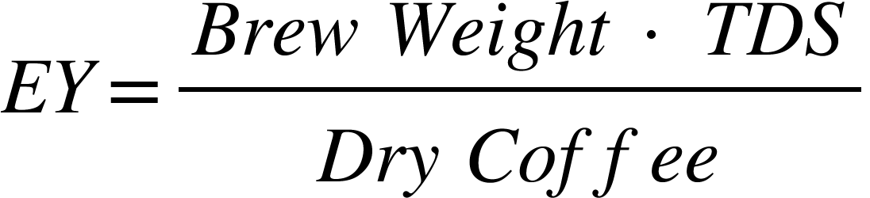

**E.g. 25 grams of coffee brewed with 425 grams of water yields a TDS of 1.27% and a beverage weight of 377 grams .**

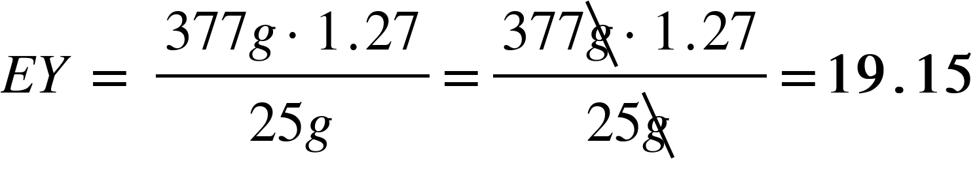

**Tasting Activity #4 Charting and Calculating Extraction Yield**

***Filter Coffee***

*Dry Coffee:*

*Brew Water Weight:*

*Beverage Weight:*

*TDS:*

*EY Calculations=*

***Espresso***

*Dry Coffee:*

*Brew Water Weight:*

*Beverage Weight:*

*TDS:*

*EY Calculations =*

#### Factors Affecting Extraction and Concentration

**Coffee to Water Ratio**

Measure ratio in grams of coffee and grams of water to keep units consistent.

Minimum ratio is _________ of dry coffee to water.

SCA Gold Cup ratio is 1:17.5 or __________

Brew ratio affects ability to achieve quality extractions and brews.

**Tasting Activity #5 Tasting changes in brew ratio**

*Write notes describing flavors, texture, and aroma for each brew*

*Brew #1*

*Ratio:*

*Measured TDS:*

*EY:*

*Notes:*

*Brew #2*

*Ratio:*

*Measured TDS:*

*EY:*

*Notes:*

*Brew #3*

*Ratio:*

*Measured TDS:*

*EY:*

*Notes:*

#### Grinding Coffee

Coffee should always be ______________________ preferably using a burr grinder or better.

After grinding the ____________ rate increases, speeding the loss of volatiles.

To ensure freshness, coffee should be brewed within ___________ of grinding, at most.

**Grinder Types**

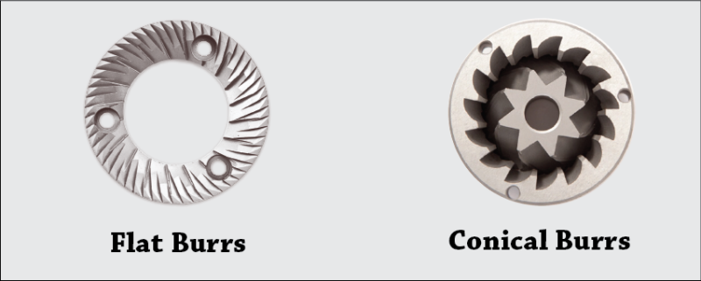

*Flat Burr*: Generally unimodal grind distribution. Generally used for filter and espresso.

*Conical*: Bimodal grind distribution, primarily used for espresso brewing.

*Roller Mill Grinders*: Large throughput grinding. Used in commercial operations. Produces a much more precise grind distribution.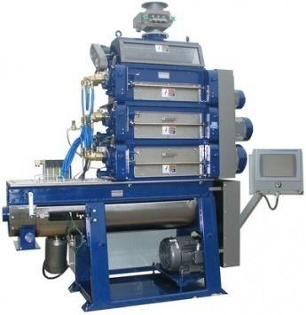

**Particle Distribution and Grind Analyzing**

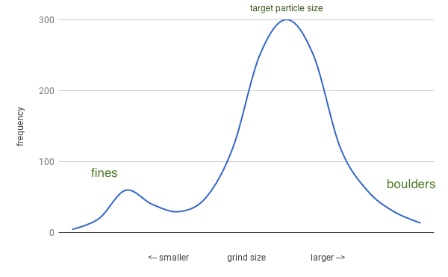

Grinding produces a range of particle sizes.

We can analyze particle sizes and their frequencies to create distribution graphs.

_________ are used to analyze grind distribution by separating the particles in to groups of size ranges, which are then weighed.

Generally lower precision analysis. The more “groups” of size ranges the higher the precision.

LASER Particle Diffraction uses LASERs to measure individual particle sizes of coffee. Measures and counts total number of particles to give a precise analysis of grind distribution.

More expensive than sieves. More complicated to operate.

Most grinds appropriate for filter brewing will have the highest percentage of particles in the range of **600-900 microns.**

**Grind Size and Brewing**

**Changes in grind size will affect the flow rate of water.** 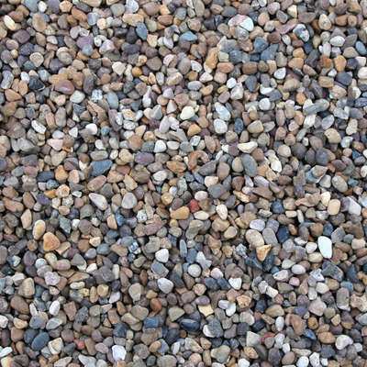

In larger, coarser particle sizes, the water will flow __________.

In smaller, finer particles, the flow rate will be ___________.

Our flow rate becomes important when considering contact time.

A ________ contact time of the water with coffee will allow more solids to be dissolved into solution.

**Tasting Activity #6 Tasting changes in contact time.**

*Write notes describing flavors, texture, and aroma for each brew*

*Brew #1*

*Contact Time:*

*Measured TDS:*

*EY:*

*Notes:*

*Brew #2*

*Contact Time:*

*Measured TDS:*

*EY:*

*Notes:*

**Changes in particle size results in changes in extraction rate because of the amount of surface area.**



Starting with a cube that has edges 6 units long. Total surface area is .



That cube with a volume of 216 units³ can be broken in to 216 smaller cubes that have edges 1 unit long. The total surface area of all the small cubes combined is .

Since surface area is how water interacts with the coffee particles and allows dissolution of solids, we can say: __________________________.

**Tasting Activity #7 Tasting changes in grind size.**

*Write notes describing flavors, texture, and aroma for each brew*

*Brew #1*

*Contact Time:*

*Measured TDS:*

*EY:*

*Notes:*

*Brew #2*

*Contact Time:*

*Measured TDS:*

*EY:*

*Notes:*

*Brew #3*

*Contact Time:*

*Measured TDS:*

*EY:*

*Notes:*

#### Water Temperature

Increasing temperature will increase/decrease extraction.

Decreasing temperature will increase/decrease extraction.

The recommended temperature range for brewing coffee is 195°F - _______ / ________ - 96°C

**Tasting Activity #8 Tasting changes in water temperature.**

*Write notes describing flavors, texture, and aroma for each brew*

*Brew #1*

*Water Temperature:*

*Measured TDS:*

*EY:*

*Notes:*

*Brew #2*

*Water Temperature:*

*Measured TDS:*

*EY:*

*Notes:*

#### Turbulence

Increases extraction through __________ and the total amount of water that comes in contact with the coffee.

Stirring, shaking, increased pulses of water, higher pressure water flow, all fall under types of turbulence.

**Tasting Activity #9 Tasting changes in turbulence.**

*Write notes describing flavors, texture, and aroma for each brew*

*Brew #1 No Turbulence*

*Measured TDS:*

*EY:*

*Notes:*

*Brew #2 With Turbulence*

*Measured TDS:*

*EY:*

*Notes:*

#### Roast Development

Changing roast profiles and development times will change the cup profile and affect ________ rates.

1st Phase: Drying

Moisture is leaving the coffee, setting initial momentum of heat change throughout the roast.

2nd Phase: Maillard (Browning)

Complex chemical reactions start occuring. Conversion of sugars and amino acids in to melanoids

3rd Phase: Development

Begins at first crack. Maillard reactions continuing. Pyrolysis starts to occur.

**Tasting Activity #10 Tasting changes in roast development.**

*Write notes describing flavors, texture, and aroma for each brew*

*Brew #1*

*Roast development:*

*Measured TDS:*

*EY:*

*Notes:*

*Brew #2*

*Roast development:*

*Measured TDS:*

*EY:*

*Notes:*

*Brew #3*

*Roast development:*

*Measured TDS:*

*EY:*

*Notes:*

#### Cold Brewing

Uses significantly longer ________________ time to achieve proper extraction using cold/room temperature water.

Different methods and ratios will produce different results.

**Tasting Activity #11 Tasting changes in cold brewing methodology.**

*Write notes describing flavors, texture, and aroma for each brew*

*Brew #1*

*Method & Recipe:*

*Measured TDS:*

*EY:*

*Notes:*

*Brew #2*

*Method & Recipe:*

*Measured TDS:*

*EY:*

*Notes:*

*Brew #3*

*Method & Recipe:*

*Measured TDS:*

*EY:*

*Notes:*

#### 

#### Filter Medium

The choice of filter for separating non-solubles from solubles will affect the cup profile.

**Paper Filters**

Paper filters will filter out most oils and other non-soluble compounds that still are extracted out of the coffee with water. Have a __________ impact on the cup profile. Disposable and do not require cleaning after brewing.

**Cloth Filters**

Will filter out most oils. Tends to have a ________ impact on cup profile as a result of loose fibers being pulled into the brew. Require cleaning, over time must be replaced due to leftover coffee oils and residue remaining in the filter.

**Metal Filters**

Do not filter out oils and non-solubles. Will ________ affect the cup profile. No filter material makes it into the cup. Requires cleaning but quality will not degrade over time.

**Tasting Activity #12 Tasting impact of filter material.**

*Brew #1*

*Filter*

*Measured TDS:*

*EY:*

*Notes:*

*Brew #2*

*Filter:*

*Measured TDS:*

*EY:*

*Notes:*

*Brew #3*

*Filter*

*Measured TDS:*

*EY:*

*Notes:*